Testing the Avocado API using Postman

1. Performing authorization to get access tokens. There seems to be no problem when performing this action. Setup

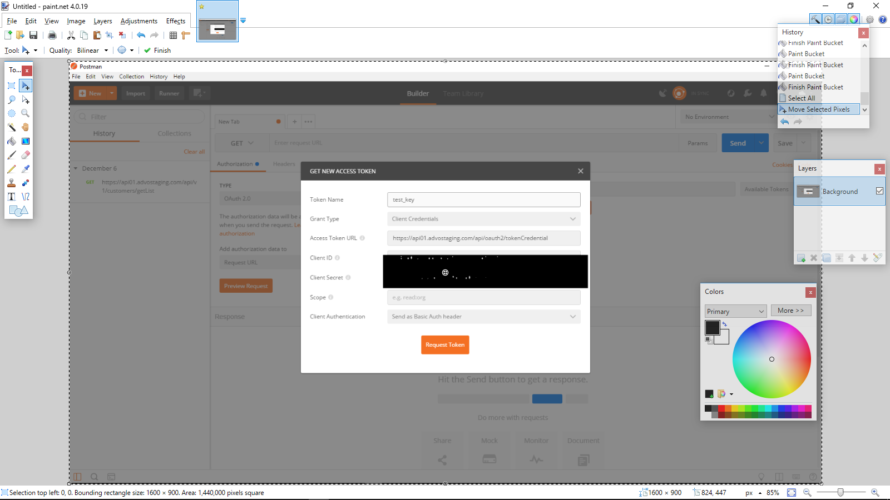

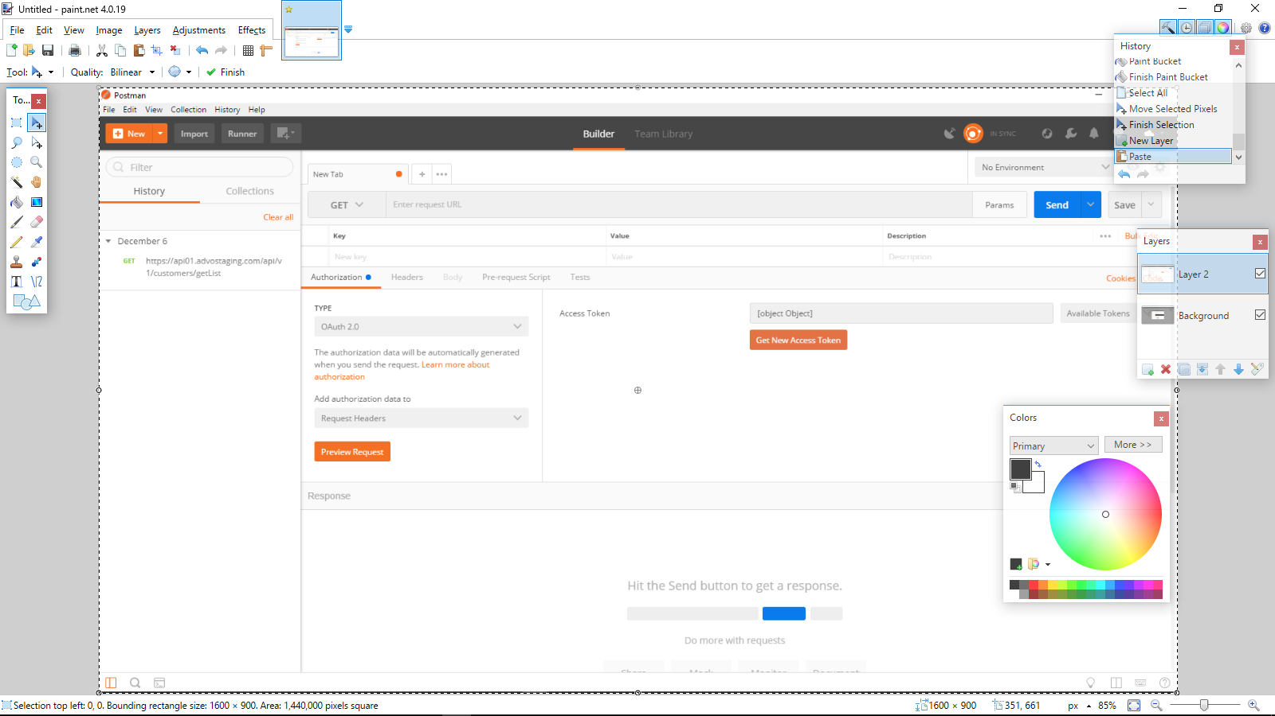

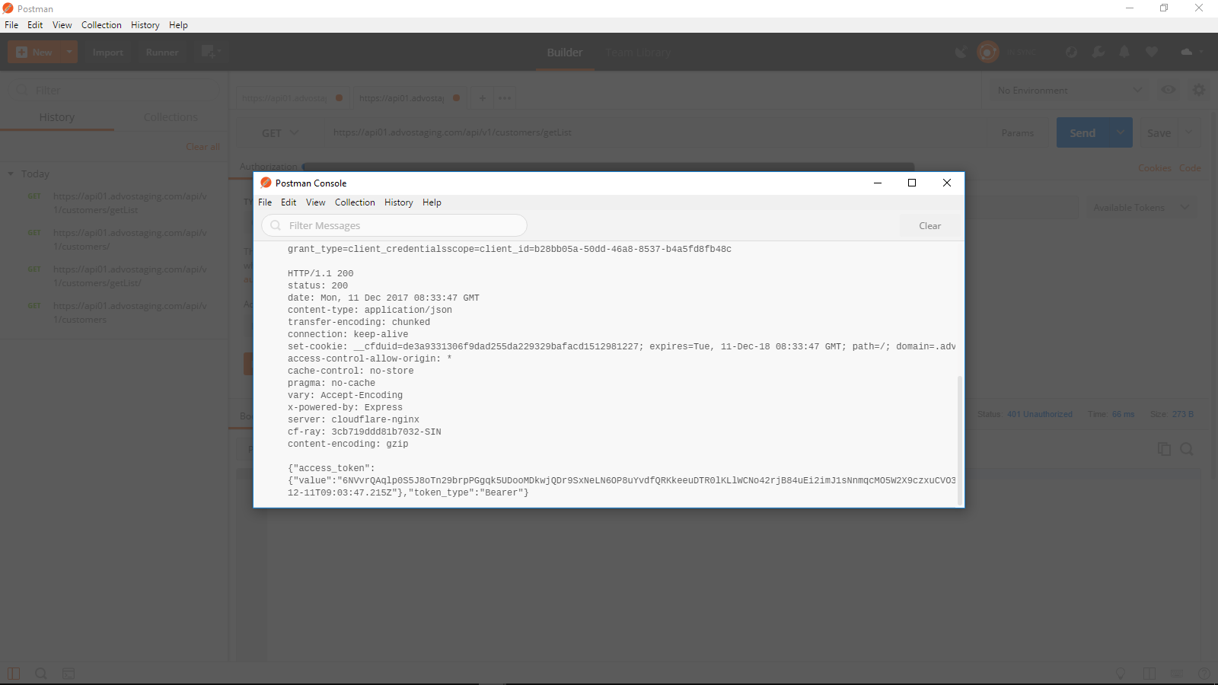

2. Using a get request to fetch merchant list, It returns bad request.

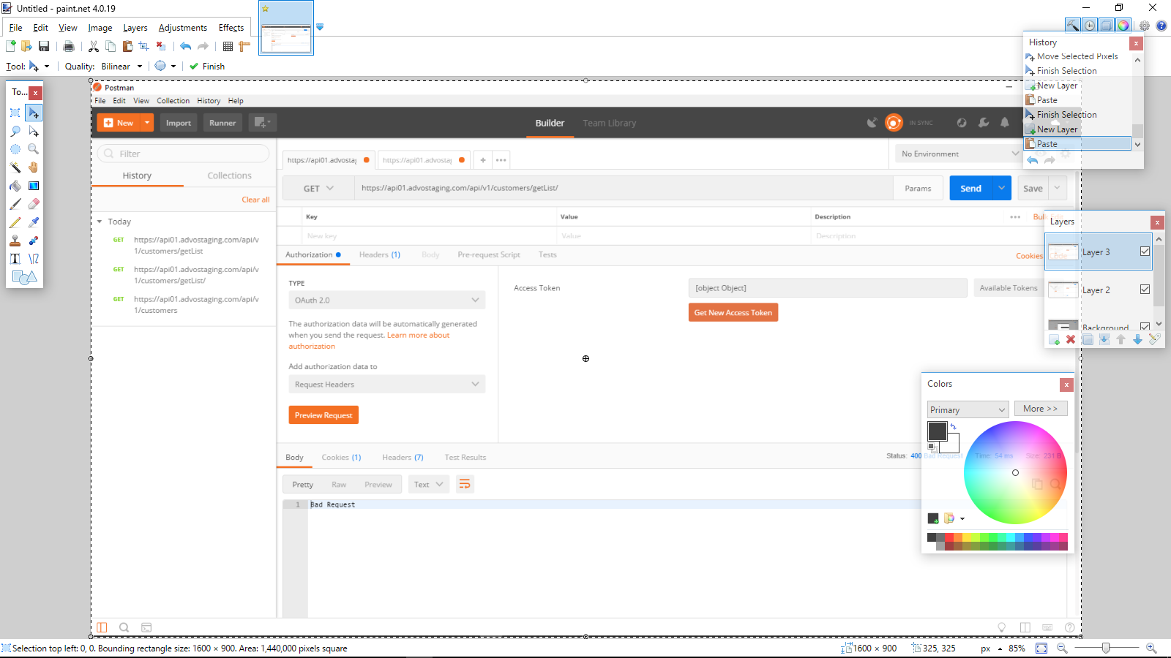

3. Removing the getList, it returns a status not found.

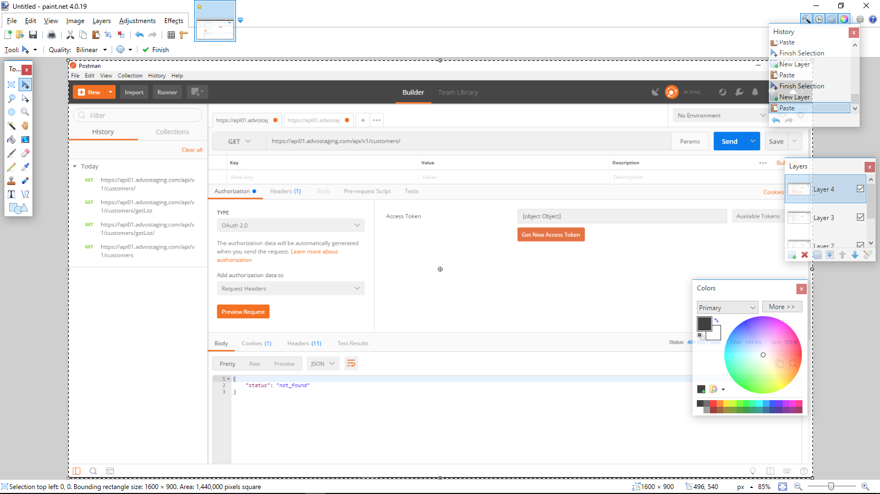

4. On the other hand, removing the OAuth2.0 and using no Auth returns unauthorized.

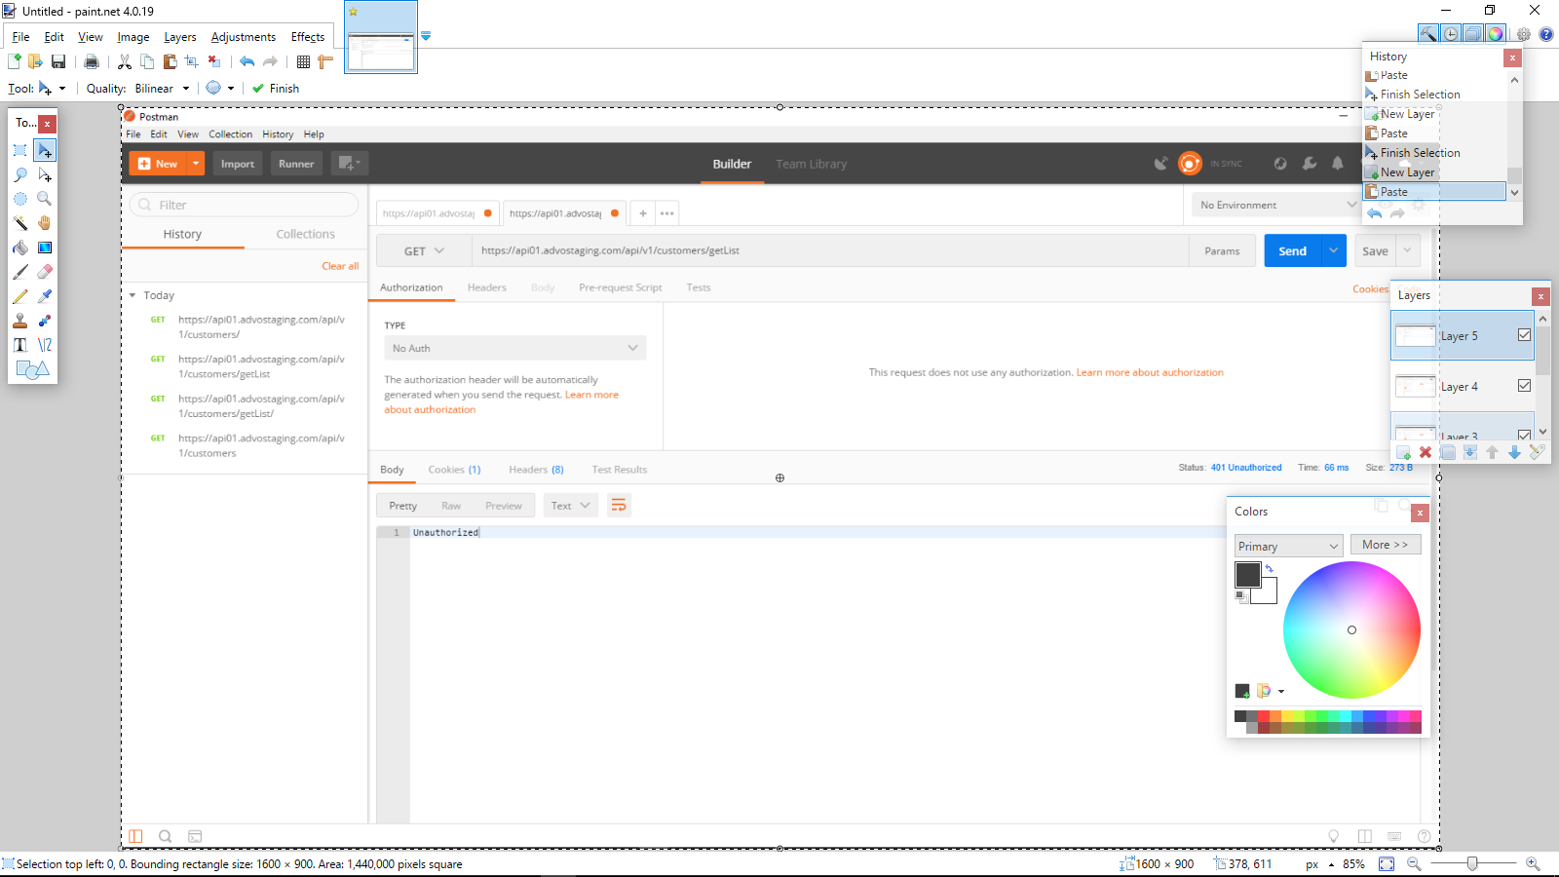

5. Changing the “add authorization data” to Request URL, returns message token is invalid.

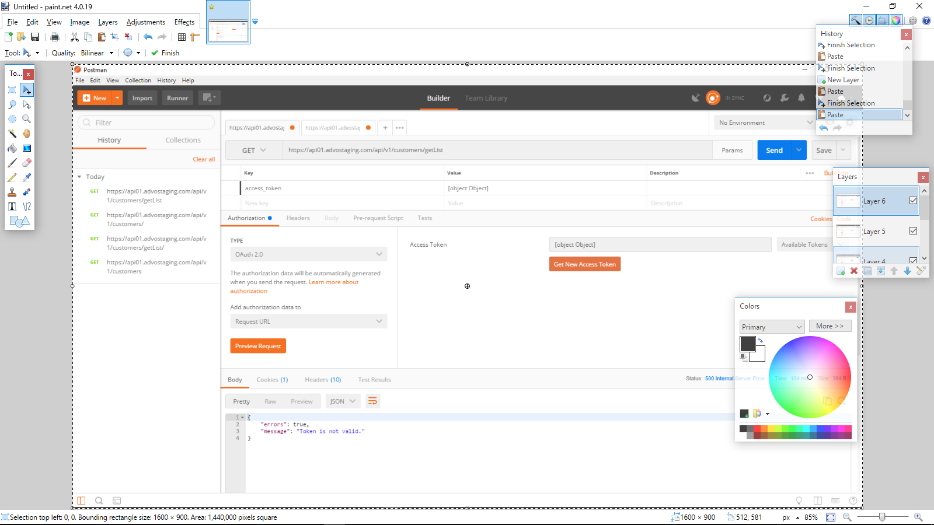

6. Still returning bad request even if I added the content type that is written on the api docs

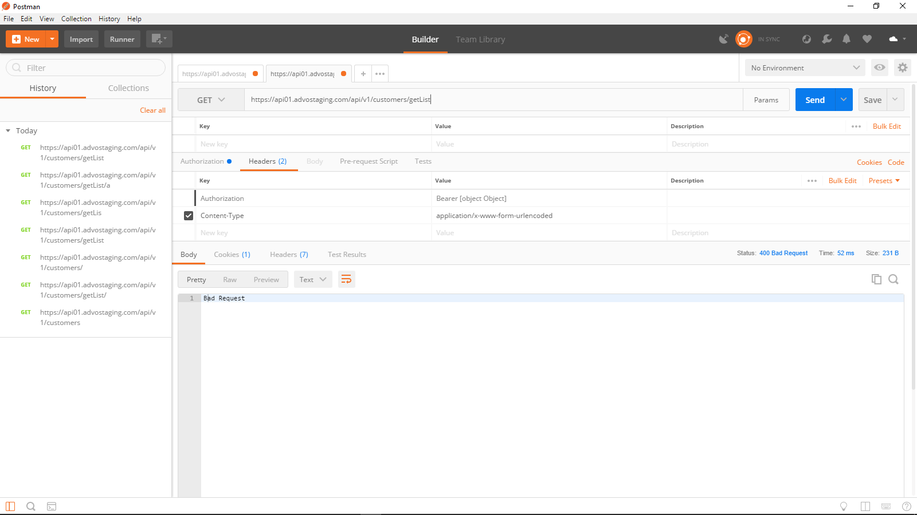

7. Using the import URL “<https://www.getpostman.com/collections/bc3b5f10a957f2e784a9>” on the API doc, it doesn’t seem to be working.

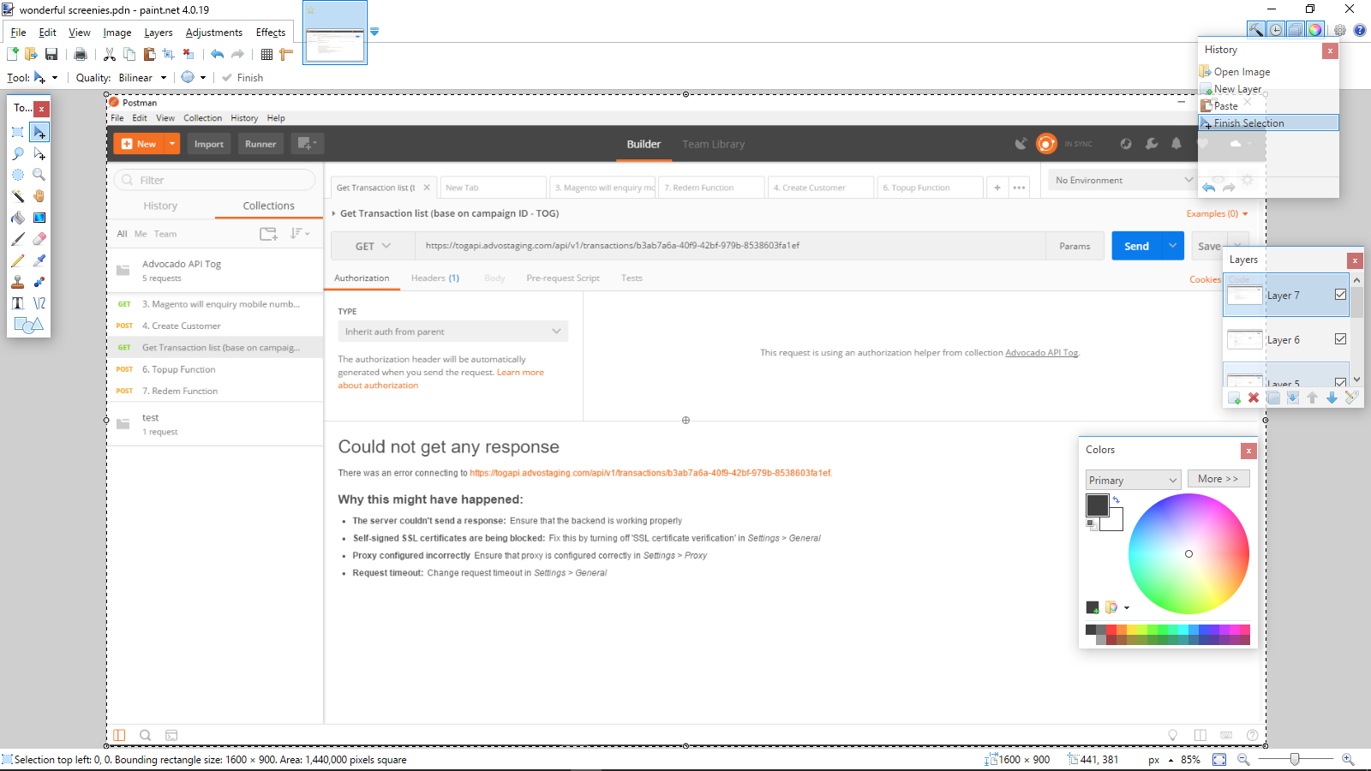

8. Copying the headers on the import url provided by the API doc, I managed to run the API and fetch an email from here “[**https://beta-app.advostaging.com**](https://beta-app.advostaging.com/)”. Though I do find the Bearer to be something odd. Also, the codes posted on the API also work, provided that I copy the headers and used it similarly on it...with Bearer on Authorization.

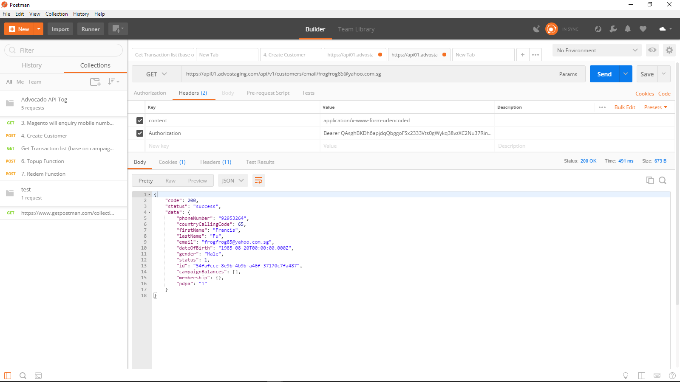

9. Scratch that. It turns out that the API is reverse regarding the Authorization. In postman, retrieving the token is in this order: token, access_type. API doc reveals that the access type must be first then token, which causes bad request on the postman. Manually adding authorization in that order allows it to run the API and retrieve the records.